**PYSPARK**

**CURRENT DATE**

**PYSPARK CODE**

import pyspark

from pyspark.sql import SparkSession spark=SparkSession.builder.appName('datefunctions').getOrCreate()

curr_dat =spark.range(2)

curr_dat.show()

from pyspark.sql.functions import current_date

date1=curr_dat.withColumn('currentDate',current_date())

date1.show()

date1.printSchema()

**OUTPUT**

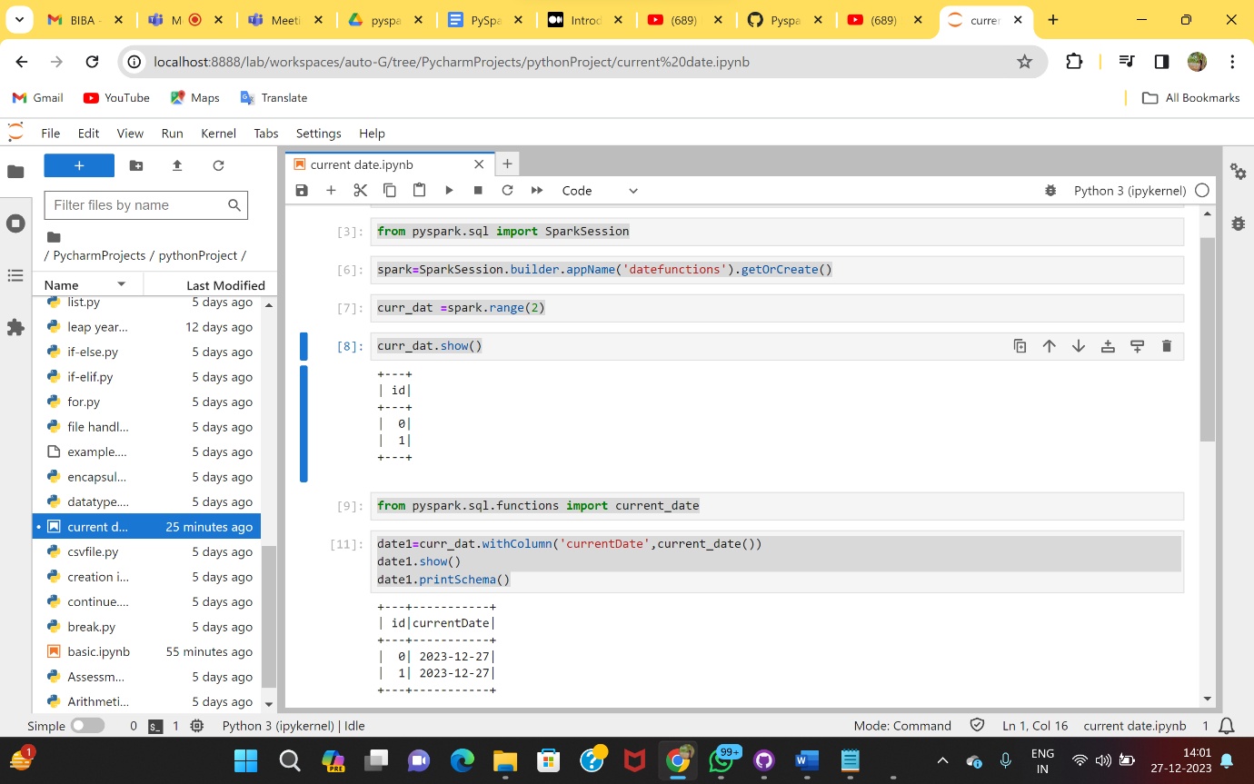

**DATE_FORMAT :**

**Code:**

import pyspark

from pyspark.sql import SparkSession spark=SparkSession.builder.appName('datefunctions').getOrCreate()

curr_dat =spark.range(2)

curr_dat.show()

from pyspark.sql.functions import current_date

date1=curr_dat.withColumn('currentDate',current_date())\

.withColumn('Dateformat',date_format('currentDate','dd.MM.yyyy'))

date1.show()

date1.printSchema()

**Output:**

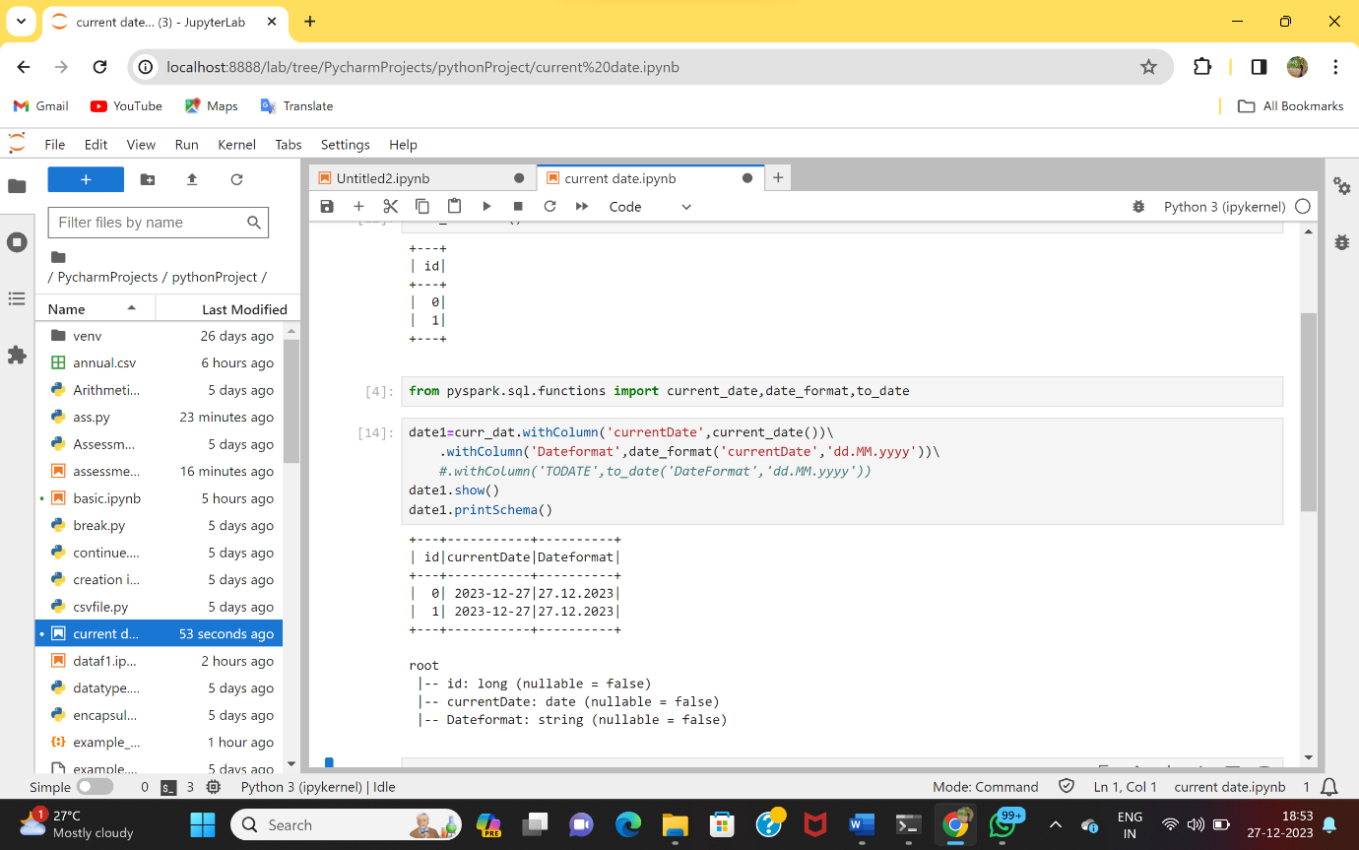

**TO_DATE()**

**Code:**

import pyspark

from pyspark.sql import SparkSession spark=SparkSession.builder.appName('datefunctions').getOrCreate()

curr_dat =spark.range(2)

curr_dat.show()

from pyspark.sql.functions import current_date

date1=curr_dat.withColumn('currentDate',current_date())\

.withColumn('Dateformat',date_format('currentDate','dd.MM.yyyy'))\

.withColumn('TODATE',to_date('DateFormat','dd.MM.yyyy'))

date1.show()

date1.printSchema()

**Output:**

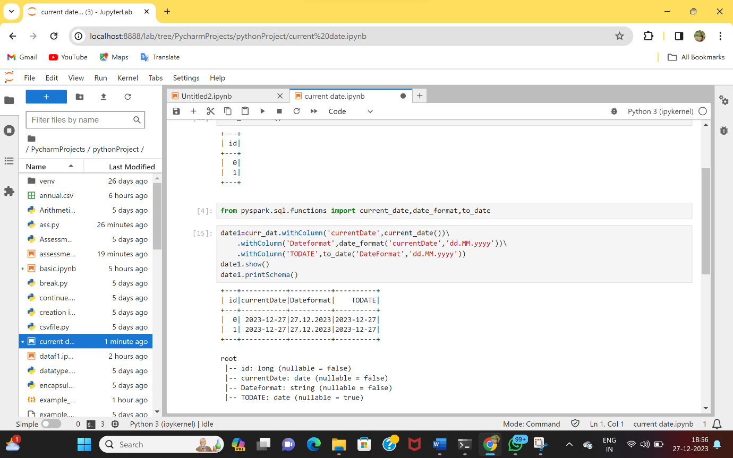

**Reading CSV :**

**Code**

from pyspark.sql import SparkSession

spark = SparkSession.builder.appName('practice').getOrCreate()

read_pyspark = spark.read.csv('test1.csv')

spark.read.option('header','true').csv('test1.csv').show()

**Output:**

